Lab Guide for Hypertext Markup Language (HTML)





Contents

Background 1
HTML Assignments 1
Assignment 1: Understanding Browsers and HTML 1
Assignment 2: Writing and Viewing Your First HTML Page 3
Assignment 3: Using Formatting Styles and Color. 5
Assignment 4: Using Hyper Links in HTML 8
Assignment 5: Using Lists in HTML 11
Assignment 6: Using Images in HTML 14
Assignment 7: Creating Tables in HTML 17
Assignment 8: Creating Interactive form using HTML. 22
Assignment 9: Working with frameset and frames 26

Background
This document contains the assignments to be completed as part of the hands on for the subject HTML.

 | Note: All assignments in this document must be completed in the sequence in this document in order to complete the course.

HTML Assignments
All the assignments in this section must be completed on Day 1 of your HTML course.
Assignment 1: Understanding Browsers and HTML

Objective: To understand the software requirements for learning HTML and work with different Browsers and editors.

Background: You have learnt the basics of HTML from IWT course. HTML file is a text file containing markup tags. HTML file can be created using a text editor. You can view the pages with a program called a Web browser.

Popular browsers are Internet Explorer(from Microsoft) and Netscape Navigator now known as Mozilla Firefox(from Netscape Communications). Opera is a very popular alternative browser. Lynx is a text browser for the World Wide Web.

Note: You can easily edit HTML files using a WYSIWYG (what you see is what you get) editor like FrontPage, Visual Interdev etc. However, these tools do not generate very optimized HTML code.As a programmer, you should be able to create and edit HTML files using text editors like Notepad or Textpad. In the entire course you are supposed to use only a text editor

Estimated time: 5 minutes

Step 1: Open Internet Explorer(Select the Start Menu-> Internet Explorer). And type http://sparsh/V1 on the Address bar.
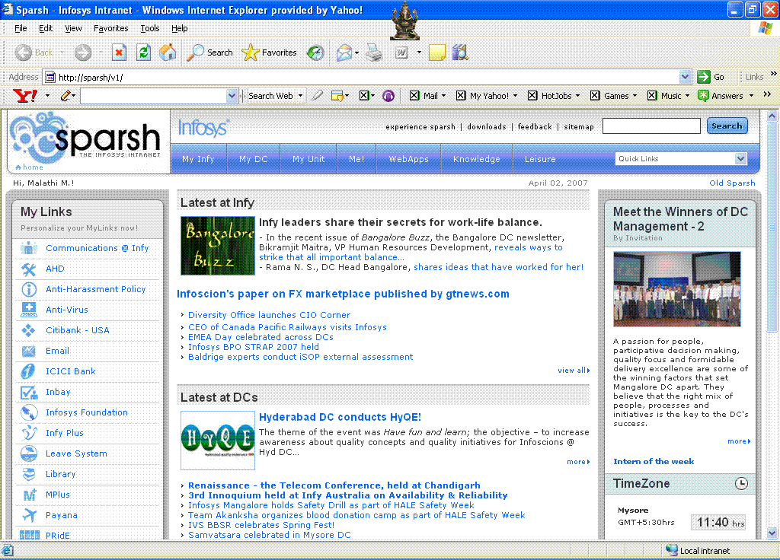

Step 2: Select menu option, view -> source. You can find the HTML tag that creates the sparsh home page.

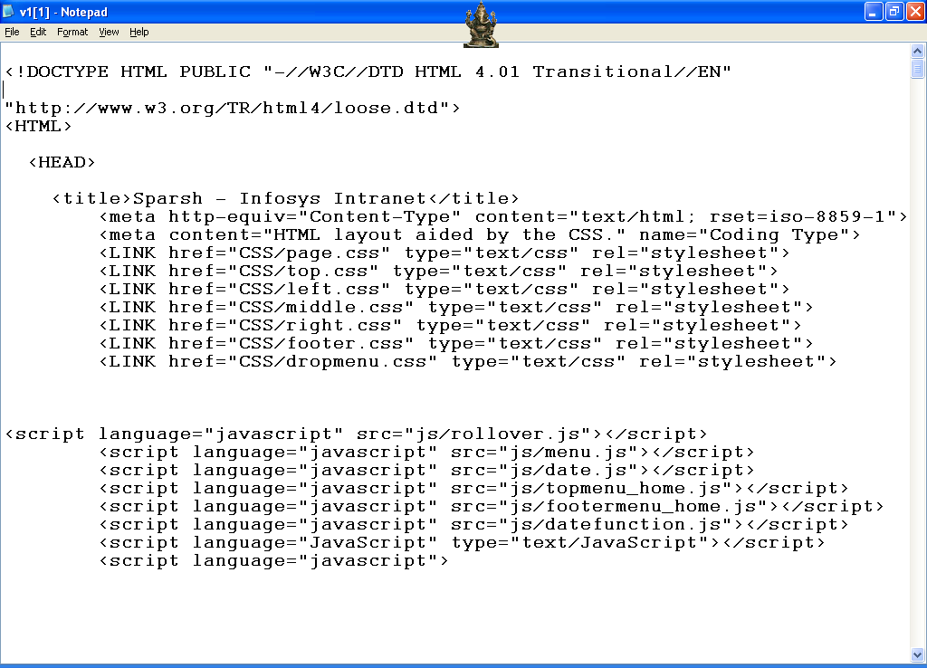

Step 3: Select menu option, Help -> About Internet Explorer. This should display the version of the Internet Explorer browser you are using.

Step 4: What is the version of Internet Explorer you are using?.

Step 5: Click on the WebApps Link and Search for a Link called DART in the page. (Hint: Use menu option Edit-> Find)

Summary of this exercise:
You have just learnt
- Using a Web Browser
- Using “View Source” feature of Web browsers to see the actual HTML code
- Finding the version of the browser
- Finding within a web page using the browser’s Find feature

Deliverables of the exercise:
Nil.

Assignment 2: Writing and Viewing Your First HTML Page

Objective: To write and view your first HTML page and to understand heading elements like <h1> to <h6> and formatting elements like <b>,<i> and <u>.

Background: You have learnt how to use a Browser. The HTML display may depend on your browser and version you are using.

Estimated time: 10 minutes

Step 1: Create a folder assign2 under your work directory (TBD: The directory structure)

Step 2: Open a text editor (In Windows, notepad.exe or TextPad and in case of UNIX, vi) and type the following:

<html>
<head>
<title> First Page</title>
</head>
<body>
<!-- Comment: The text below appears in heading style 2 -->
<h2> This is my first HTML page </h2>
</body>
</html>

Here, the text enclosed between <h2> and </h2> will appear in heading style2 font.

Save the file as “firstpage.html” in the directory Assign2.

(while saving choose Save as type to be “All files”)

Note: An HTML file must have an .htm or .html file extension. HTML tags are not case sensitive, <b> means the same as <B>. The World Wide Web Consortium (W3C) recommends lowercase tags in their HTML 4 recommendation, and XHTML (the next generation HTML) demands lowercase tags.

Step 3: Double click on the firstpage.html (or) Open the browser, and select menu option File -> Open.

Step 4: Type the following code in a text editor and save the file as “firsterror.html”.

<html>
<head>
<!-- Comment: There may be an error here -->
<title> First Page With Errors<title>
</head>
<body>
<h2> This is my first HTML page </h2>
</body>
</html>

Step 5: Open the firsterror.html file in a browser. What is the output? Why?

Step 6: Find the Errors in “firsterror.html” and correct it. Change the title as “First Page Without errors”.
Hint: All the tags are not closed. Try and find out which tag is not closed before going to Step 7.

Step 7: Notice that the closing ‘title’ tag has a missing ‘/’. Change the closing title tag to </title>

Note: All browsers contain an HTML interpreter, which interprets HTML tags so that headings, hyperlinks, tables, etc. appear as intended on the page. Interpreter is a program that reads source code one statement at a time, translates that statement to machine language, executes the machine language statement, then continues with the next statement.

Step 8: Create a new HTML page with your name and Address and save it as “address.html”, use <br> tag for line breaks.

Step 9: Display name in BOLD , address in ITALIC and underline the pin code.
Text between “<b> “ and “</b>” tags appear in bold.
Text between “<i> “ and “</i>” tags appear in italic.
Text between “<u> “ and “</u>” tags appear in underline.

Step 10: Create a HTML page and display name and address of three of your friends in a readable format. Save it as “addressfriends.html”.

Step 11: Create a page with the following details and save it as “headings.html”.
President -> Display in <h1> heading Style
Managing Director -> Display in <h2> heading Style
HOD -> Display in <h3> heading Style
Manager -> Display in <h5> heading Style
Worker -> Display in <h6> heading Style

Summary of this exercise:
You have just learnt
Creating HTML page.
Debugging HTML pages.
<br> , <i>, <u>and <b> tag.
Heading Tags (h1 to h6).

Deliverables of the excercise:
- firstpage.html
- firsterror.html
- address.html
- addressfriends.html
- headings.html
Assignment 3: Using Formatting Styles and Color.

Objective: To understand adding of background color to a page, adding color to a text and usage of <font> tag.

Estimated time: 10 minutes

Step 1: Type the following code and save it as “bgcolor.html” in a folder called assign3.
<html>
<head>
<title> Page with background Color</title>
</head>
<!—Comment: The bgcolor attribute value is a RGB value -->
<body bgcolor="#FF00F0">
<h3> Webpage with Background <u>Color</u></h3>
</body>
</html>

Verify your output?
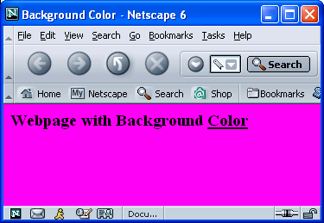

Note: RGB Color Components.
Color attribute values give a color definition. Colors are defined using a hexadecimal notation for the combination of Red, Green, and Blue color values (RGB). The lowest value that can be given to one light source is 0 (hex #00). The highest value is 255 (hex #FF). A collection of color names like blue, green, cyan etc. are also supported by most of the browsers.

Step 2: Modify your HTML page change the bgcolor attribute value as "#009192".

Step 3: Type the following code and save it as “fontcolor.html”.
<html>
<head>
<title> Paragraphs and Color</title>
</head>
<body bgcolor="cyan">
<!-- Comment : <p> Defines Paragraphs in HTML -->
<p>
All browsers contain an HTML interpreter, which interprets HTML
tags so that headings, hyperlinks, tables, etc. appear as intended on the page.
</p>
<!-- Comment : The <font> tag specifies the font properties -->
<font color="#0000FF" face="Monotype Corsiva" size="5">
Interpreter is a program that reads source code
one statement at a time, translates that statement to
machine language, executes the machine language statement,
then continues with the next statement.
</font>
</body>
</html>

Step 4: Open the “fontcolor.html” in a browser.

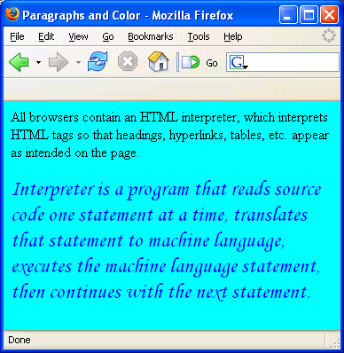

Here <p> is used to display paragraphs and font used to set the font properties like color, face and size. The Font size can take a number from 1 to 7.

Note: In HTML the font size is limited to 1 to 7. In future you can use CSS(Cascading Style Sheets) for changing the properties. ie you can have a font with size 10 cm. The font face value depends on the fonts available on the system. Defaults fonts like “Arial”, “Times New Roman”, and “Courier” are available in all Systems.

Note: There are several reasons why HTML attribute values are inside double quotes in HTML, although you can use single quotes or without quotes. In XHTML attributes should be inside double quotes. The entire course you are supposed to use attribute values inside double quotes.

Step 5: Modify the “fontcolor.html”, add align attribute to the <font> tag. ? What is the output? Try all values for align attribute.

Note: HTML elements permitted within the BODY are classified as either block-level elements (or) inline elements. Block-level elements typically contain inline elements and other block-level elements. Block-level elements usually begin on a new line.

Step 6: Verify <font> tag is an inline element or block-level element with an example.

Step 7: Modify the “fontcolor.html” add the following code.
<center>
<font color="#0000FF" face="Monotype Corsiva" size="5">
……………………………………………………………………………………………………………………………………………….
</font>
</center>

Note: <center> tag centers its enclosed text horizontally.

Step 8: Modify the “fontcolor.html” add a <hr> tag and save as “hr.html”.
<hr> tag is used to display a horizontal line.

Step 9: Include the width, size and color attribute to the <hr> tag.
Ex: <hr width=”70%” size=”10” color=”#00FF00”>

Summary of this exercise:
You have just learnt
Using background color for html page.
Using <p> and <font> tag.
The <hr> tag.

Deliverables of the exercise:
- bgcolor.html
- fontcolor.html
- hr.html

Assignment 4: Using Hyper Links in HTML

Objective: To understand and create hyperlinks in HTML and using image as hyperlinks.

Estimated time: 15 minutes

Step 1: Create an HTML page with some contents and save it as “linkdisp.html” in a folder called assign4.

Step 2: Create an HTML page with a hyperlink to the “linkdisp.html” and save it as “link.html”.
Ex: <a href=”linkdisp.html”>Link Disp Page </a>

Note: When you are creating links to documents and images on the Web the path can be two ways 1) Absolute path and 2) Relative path.

Absolute paths refer to the very specific location like “c:\html\assign2\fontcolor.html” (or) “http://sparsh/WebApps/dart/dart1.htm”. It is a good idea to use absolute paths, without the domain name. ie like “/WebApps/dart/dart1.htm”. Always use forward slash(“/”) to separate path to achieve platform independent.( In all Operating Systems).

Relative paths change depending upon what page the links are located. Links in the same directory as the page have no path information listed. Sub-directories are listed without any preceding slashes like “Assign2_sub/test.html”. Links up one directory are listed like “../Assign2/firstpage.html”.

Step 3: Create a HTML page called “linkpage.html” and store it in Assign2 folder. Give relative links to the following files.
- link.html (Hint: Same folder)
- assign2/firstpage.html (Hint: Links up one directory)

Step 4: Modify the “linkpage.html” and add two more links to the following sites.
- http://kshop
- http://www.yahoo.com

Step 5: Add link, alink and vlink attributes to the <body> tag.
Ex: <body link=”blue” vlink=”red” alink=”green”>
<a href=”http://kshop/kshop/default.asp”>

Here link stands for the color of the link, vlink stands for the color of the visited link and alink stands for the active link. (All these apply only to that particular page).

Note: If the link is displaying still in visited color, Select menu option Tools-> Internet Options -> Clear History and refresh the page ( Press F5 Button). The standard color for a link is blue in all browsers. It is always advisable to use standard color only for the links.

Step 6: Create an html file with more than one page content, save it as “samelink.html”. Open the page in Browser and make sure that the vertical scrollbar is enabled.

Step 7: Create a link on the bottom of the page so that it can go back to the top of the page when you click on it.

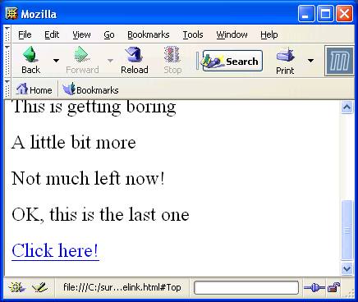

Hint: <a name=”top”>Top of The Page</a>
…………………………………………………………………………
Contents……………………………………………………
…………………………………………………………………………
<a href=”#top”>Click here!</a>
<a name=”bot1”>Bottom of the Page</a>

Step 8: Open “link.html” and add a link to samelink.html, when it opens it should show the bottom of “samelink.html”?

Hint: Use <a href=”samelink.html#bot1”>Open Samelink Bottom</a>

Step 9: Type the following code and what is the Error in that?
<a href=”samelik.html>Same link <a>

Step 10: Check all the double quotes are closed?

Summary of this exercise:
You have just learnt
Using hyperlink.
Absolute path and Relative path.
Hyperlink to the same document.

Deliverables of the exercise:
- linkdisp.html
- link.html
- linkpage.html
- samelink.html
Assignment 5: Using Lists in HTML

Objective: To understand how to create ordered, unordered and definition lists in HTML.

Estimated time: 5 minutes

Step1: Create an html page and save it as “ord_list.html”, should look like the following demo.

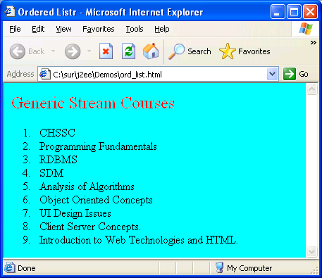

Step2: Display the above list numbering in a,b,c instead of 1,2,3.
Hint: Change the type attribute of <ol> tag, the type attribute values are A, a, i, I, 1.

Step3: open “ord_list.html” and save as “unord_list.html”, change the numbering list to bulleted list.


Step 4: change the <ul> type attribute to “square”. The possible values are square, disc and circle.

Step 5: change the <ul> type attribute to “mystyle”. What is the out put? Why?

Note: If the attribute value is not defined in HTML specification the default value will be assigned. The type attribute values are disc, square, circle .

Step 6: Create a Definition list that look like the following demo and save it as “def_list.html”

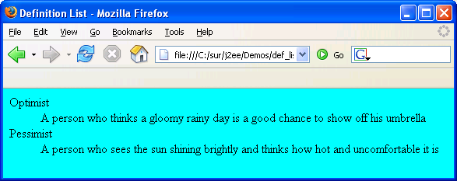

Step 7: Create a html page should look like the following and save as “nested_list.html”.

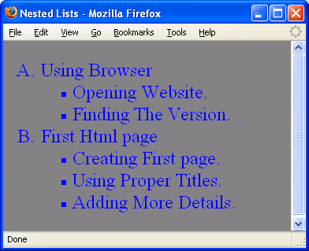

To provide the font style put the entire list inside a <font> tag.

Summary of this excercise:
You have just learnt
Ordered List
Unordered List
Definition Lists
Nested List.

Deliverables of the excercise:
- ord_list.html
- unord_list.html
- def_list.html
- nested_list.html

Assignment 6: Using Images in HTML

Objective: “A picture is worth a thousand words”. We will be learning how to use images in your HTML page.

Estimated time: 15 minutes

Step 1: Create a folder called assign5.

Step 2: Select Start Button->Search->For Files or Folders.

Step 3 : Choose the link All Files and Folders. Type *.jpg in “all or part of the filename.”

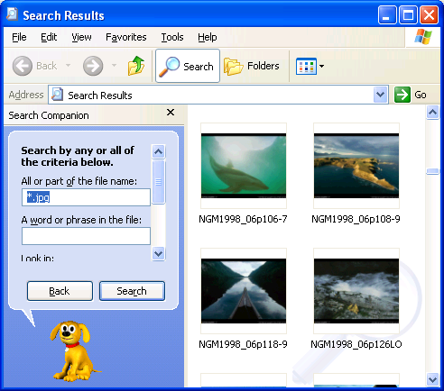

Step 4: copy some image files to the Assign5 folder.

Note: Web pages require JPG (or) GIF (or) PNG image types. On the web, JPG is the best choice (smallest file) for photo images, and GIF is common for graphic images because GIF supports transparent color feature. PNG was designed recently, but it's appeal is growing as people discover what it can do. Most of the Browsers can not show BMP images.

JPEG: Joint Photographic Experts Group.
GIF: Graphic Interchange Format.
PNG: Portable Network Graphics Format.

In Windows XP and beyond you can create image files(.jpg, .png, .gif)using Microsoft paint. Use Start button -> Programs -> accessories -> paint. For saving the image use menu option -> File ->Save, Select the save as type for selecting the particular format.( .bmp, .jpg, .gif, .png, etc.)

Step 5: Create a HTML page with two images and save it as “img.html” in assign5 folder.
Hint: <img src=”img11.jpg” alt=”Image1 1 image”>. The name of the image should exist in your folder.(You can use absolute or relative path for images)

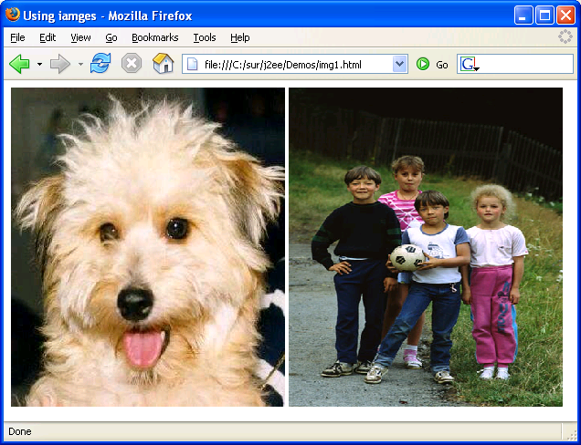

Note: Some elements do not have closing tags (known as empty tag). They do not affect a block of the document in some way. These elements do not require an ending tag. <img> is an empty tag. You can use like <img src=”s1.jpg” />

In case the image is missing or the browser is not a graphical browser (e.g.Lynx), the alt text is displayed in place of the image. Text specified inside alt is shown as tool tip text.

Step 6: Identify two empty elements from your previous assignments.

Note: If width and height is different from the actual size of the image, quality of the image may be degraded.

Step 7: Include two more images with suitable size. Use width and height attribute for resizing the image size and save the file as “img1.html”.
<img src=”s1.jpg” width=”300” height=”400”>

Step 8: Add some text to the img1.html and align the text messages in to left of the image.
Hint: Use align attribute of <img> tag the values can be left, right, top, bottom etc.
<img src=”s1.jpg” align=”right”>

Step 9: Create an image link to the img.html and save the file as “imagelink.html”.
Hint: place the <img> tag inside the <a> tag.
<a href=”img.html”><img src=”kid.jpg”></a>

Step10: What about making an image as background for the entire page and save it as “imgbackground.html”. Try like this
<body background=”kids.jpg”>

Summary of this excercise:
You have just learnt
JPEG anf GIF Iamges.
<img> tag and attributes.
Aligning the images.
Creating an image link

Deliverables of the excercise:
- Img.html
- img1.html
- imagelink.html
- imgbackground.html

Assignment 7: Creating Tables in HTML

Objective: How to create tables in HTML and layout the pages using invisible tables.

Note: To create table use the combination of the following tag.
<table> The main tag. Used to tell the browser "this is a table".
<tr> TableRow defines a horizontal row.
<th> TableHead defines a cell (or) heading of the column.
<td> TableData defines a cell (or) column.

Estimated time: 15 minutes

Step1: Type the Following code in to an html file and save it as “tab1.html”.

<!--Comment: border=”2”, indicating the border width of the table-->
<table border=”2”>
<tr>
<!-- Comment: Tag th is for giving a table heading-->
<th> Name </th><th>Empno</th>
</tr>
<tr>
<td>Jack</td><td>1001</td>
</tr>
<tr>
<td>John</td><td>1002</td>
</tr>
</table>

Step 2: Change the border attribute value to “0” and observe what will be the output?

Step 3: Change the table tag to <table border=”2” width="50%">.

Step 4: Right click on the desktop, select properties menu and settings tag. Find out the resolution of your PC. (It may be 1024 x 768 pixels)

Note: Table width will determine how much of the browser space (horizontally) will be used to display your table. There are two basic ways to accomplish this by percent and by pixels. Pixels can be thought of as the smallest logical unit for display. Pixel resolution can vary from PC to PC. Tables built with percents will occupy that percentage of the browser’s visible area or the container area.(A table which is inside another table will take the percentage width based on the container table).

Step 5: Include a background color for the table. Can you? Save the file as “tabcolor.html”
<table border=”2” width="50%" bgcolor="#CDCA8F">

Step 6: If it is possible to add a background color, try to give a background image for the table.
<table border=”2” width="50%" background="s1.jpg">

Step 7: Include a background color for a particular row.
Hint: Use bgcolor attribute for the <tr> tag

Step 8: Increase the space between two cells and save it as “tabspace.html”.
<table border=”2” width="50%" cellspacing="10">

Step 9: Increase the space between the cell and the content.
<table border=”2” width="50%" cellpadding="20">

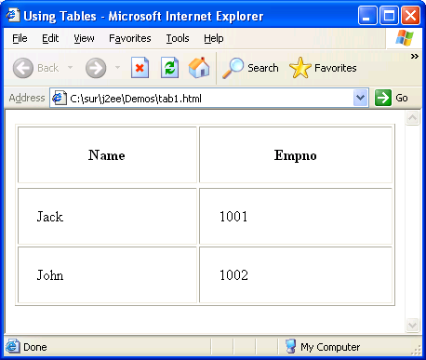

Step 10: Can you give some color and size for the table elements?
Hint: Use <font> inside a <td> tag.

Note: Do you need to give <font> tag for each cell? If you want font effect for all the cells you need to give. In future you can use CSS for avoiding the repetition of the HTML tag for providing style.

Step 11: Create the following HTML table and save it as “tabspan.html”.

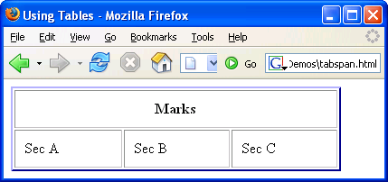

Verify the code.
<table border=”2” width="90%" cellpadding="10" bordercolor="blue" >
<tr>
<!-- Comment: colspan = ”3” indicates that the table heading Marks will span three columns-->

<th colspan="3">Marks</th>
</tr>
<tr>
<td>Sec A</td><td>Sec B</td><td>Sec C</td>
</tr>
</table>

Note: The colspan attribute of the <td> (or) <th> tag Indicates the number of columns this cell should span and rowspan indicates the number of rows this cell should span.

Step 12. Create the following HTML table and save it as “tabspannew.html”.

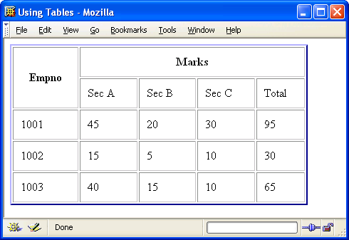

Hint: Use rowspan for the 1st cell and colspan for the 2nd cell.

Note: Tables are used in websites for two major purposes.
  - The primary purpose of arranging information in a table
  - The more widely used purpose of creating a page layout with the use of hidden tables.
(border attribute values set to “0”)

Step 13. Create the following HTML table and save it as tablayout.html.

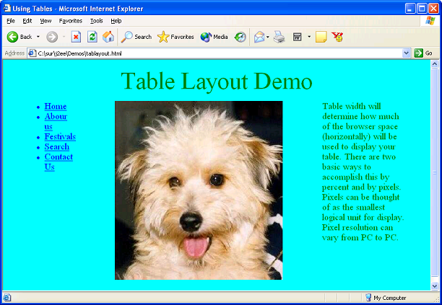

Hint: The above webpage created using a table with one row and three columns. The border of the table is invisible to the users.

The <center> tag is used align the content to the center of the container. The width attribute of the <td> tag used to specify the width of the column and valign tag is used to align the content vertically in a cell. The valign values are top, middle, bottom and baseline.

1) Replace the first cell content with unordered list of hyper links.
2) Replace the second cell content with an image.
3) Replace the third cell content with a paragraph.

Summary of this exercise:
You have just learnt
Creating tables and using Attributes
Using rowspan and colspan with <td>
The align, width and valign tag.
The table layout.

Deliverables of the exercise:
- tab1.html
- tabcolor.html
- imgbackground.html
- tabspace.html
- tabspan.html
- tabspannew.html
- tablayout.html
Assignment 8: Creating Interactive form using HTML.

Objective: To understand designing interactive forms in HTML.

Note: Forms enable users to submit information that can be used to create an interactive web application ranging from an order entry system to an email application.

Estimated time: 25 minutes

Step 1: Type the following code into a HTML page and save it as “login.html”.

<h3>Login Screen</h3>
<!-- Comment : form elements should be inside a form tag -->
<form name="f1" method="post" action="Login.jsp">
<!-- Comment : size attribute specifies the size of the text box-->
Username<input type="text" name="txtuname" size="20"><br><br>
<!-- Comment : password is similar to text, but displays only “*” -->
Password<input type="password" name="txtpasswd" size="20"><br><br>
<!-- Comment : submit button used to submit the form to the server -->
<input type="submit" value="Submit" name="sub">
<!-- Comment : reset button used to reset the form elements to the
default vale -->
<input type="reset" value="reset" name="res">
</form>

Verify your output.

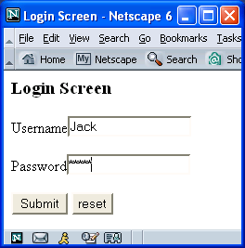

Note: In a <form> the method attribute value is either POST or GET. Data in any form submitted with the GET method is sent as part of the URL and form data submitted with POST is sent in the HTTP request body. Action attribute indicates a program on the server that will be executed when this form is submitted.
The Submit button calls the action page on the server and reset button resets the form element values to the default value.

Step 2: create a HTML page that will display a multiple choice questions with four choices and save it as “formquestion.html”.

Hint: Use Radio Buttons.

Here “Answer” is visible to the user and the value “1” is not visible to the user, which is used by either client side program or server side program

Note: All the radio buttons should have the same name (known as radio group), so that you can select only one choice at a time.

Step 3: Include a descriptive type question in to the “formquestion.html”.

Hint: Use a text area for accepting the result.

Here the cols attribute will define the width of the textarea and rows attribute will define the height of the textarea.
Note: <textarea>is a separate tag unlike <input> tags. <input> tag without any attribute will result in to a textbox.
The text between <textarea> and </textarea>, will appear as the default value for the textarea. To set a default value for a text box you can sue <input type=”text” value=”Infosys”>.

Step 4

Note: Some special elements.
<input type=”file”> : This control is used for file uploading.
<input type=”button”> : This control used to create a button that has no predetermined actions(rest (or) submit).
<input type=”hidden”> : Used to store some temporary data(hidden) that can be accessed by client side or server side programs.
<input type=”image”> :This control is used to create a graphical version of the submit button.

Note: Some special attributes.
name and value are the common attribute for all the <input> elements.
maxlength : sets the maximum number of characters allowed in the field. Applicable only to text, hidden and password elements.
checked : To set a checkbox (or) radio button to be selected by default.
selected : An occurrence of the selected attribute in the <option> element sets the form select control to select this item by default.

Step 6: open “applyform.html” and change border=”0” in the table tag.

Summary of this exercise:
You have just learnt
Creating a login screen.
Designing GUI using HTML.
Using <textarea> and <select>
Aligning form elements using tables.

Deliverables of the exercise:
- login.html
- formquestion.html
- formdob.html
- tablayout.html
- applyform.html
Assignment 9: Working with frameset and frames

Objective: To Understand how to display more than one HTML document in the same browser window. With frames, you can display more than one Web page in the same browser window.

Note: The frameset element defines a frameset. It is used to organize multiple windows (frames). Each frame holds a separate document. The frameset element states only how many columns or rows there will be in the frameset. You must use the cols or the rows attribute. The frame element defines a sub window (a frame).

Estimated time: 25 minutes

Step 1: Open a text editor and type the following:

<html>
<!--comment: Two Columns of 30% and 70% each -->
<frameset cols="30%,*">
<!--comment: * is indicating the remaining space (here 70%) -->
<!-- Comment: frame1.html is for the first frame -->

<frame src="frame1.html">
<!—Comment: frame2.html for second frame -->

<frame src="frame2.html">
</frameset>
</html>
<!--comment: no need to use body tag at all-->

Save the file as “frameset1.html”.

Note: The two html pages frame1.html and frame2.html should be present and resides in the same directory. The <frameset> tag is used instead of the <body> tag.

Step 2: open the “frameset1.html” in the browser.

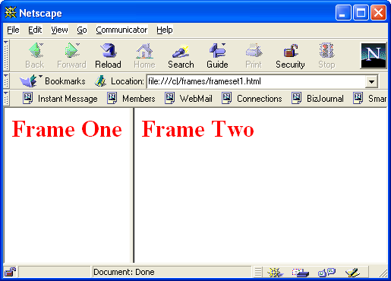

Step 3: Type the following code in a text editor and save the file as “frameset2.html”.

<html>
<frameset cols="40%,*">
<!—Comments: Divides the window into two cols -->
<frameset rows="35%,*">
<!—Comments: Divides the first frame(Col of width 40%)into two rows-->
<frame src="frame1.html" name=”f1”>
<frame src="frame2.html" name=”f2”>
</frameset>
<frame src="frame3.html" name=”f3”>
</frameset>
</html>

Step 4: open the “frameset2.html” file in a browser.

Step 5: Create the following HTML page and save it as “frameset3.html”

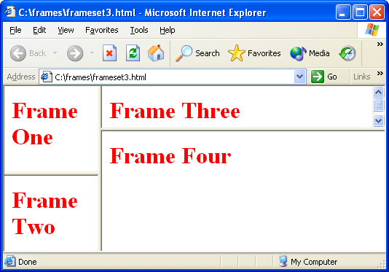

Step 6: modify the “frameset3.html” file and save it as frameset4.html. Do the following
- Make the frame border invisible to the user.
- Prevent the user from resizing the frame.
- Disable the scrollbars.
Hint: Set the attribute frameborder=0 for the <frameset> to disable the border.
Set the attribute NORESIZE for the <frame> to disable resizing of the frame
Set the attribute SCROLLING=NO for the <frame> to disable scrolling.

Step 7: Type the following code and save it as “mainframe.html”

<html>
<frameset cols="30%,*">
<frame name=”frame1” src="doc1.html">
<frame name="frame2" src="doc2.html">
</frameset>
</html>
Note: The name attribute values are case sensitive.

Step 8: Type the following code and save it as “doc1.html”

<html>
<body>
<h1><font color=red>Frame One</font></h1>
<a href="http://sparsh/v1" target="frame2">Go To Sparsh</a>
</body>
</html>

Step 9: Type the following code and save it as “doc2.html”

<html>
<body>
<h1><font color=red>Frame Two</font></h1>
<h2> Use target attribute of the &lt;a> element to set the target for the anchor</h2>
</body>
</html>

Step 10: Open “mainframe.html” in the browser.

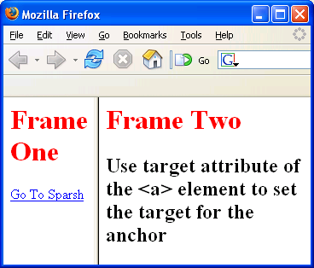
Step 11: Click on the link “Go To Sparsh”.

Note: Ensure frame naming in frame tag. Predefined target values for <a> are
_blank – Loads link into new blank window
_parent - Loads the link into the immediate parent of the document the link is in
_self - Loads the link into the same window. (Default)
_top - Loads the link into the full body of the window.

Step 12: Modify doc1.html and set the target value as “_parent”. And check for the output.

<a href="http://sparsh" target="_parent">Go To Sparsh</a>

Step 13: Type the following code and save it as “top.html”.

<html>
<frameset cols="30%,*">
<!-- Comments : mainframe.html is a frame, contains doc1.html and doc2.html-->
<frame name="frame1" src="mainframe.html">
<frame name="frame2" src="doc2.html">
</frameset>
</html>

In “doc1.html” change the target as “_top”.
<a href="http://sparsh" target="_top">Go To Sparsh</a>
Open in the browser and verify the output.

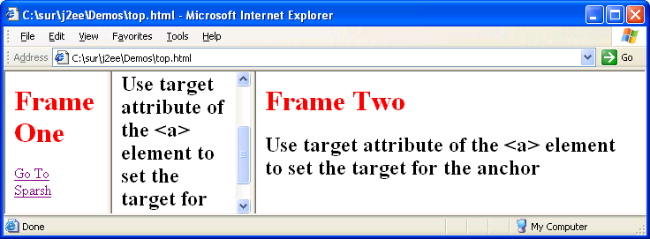

Note: The iframe element creates an inline frame that contains another document. This is another form of frame, called as floating frame. An inline frame is created by <iframe> element and can occur anywhere the <body> tag.

Summary of this exercise:
You have just learnt
Working with frames
<frameset> and <frame> tag.
Using target attribute of <a> tag with frames.

Deliverables of the exercise:
- frameset1.html
- frame1.html
- frame2.html
- frameset2.html
- frameset3.html
- mainframe.html
- doc1.html
- doc2.html
- top.html
- floatframe.html

Try It Yourself:

1. Write the HTML to list the names Mickey, Minnie, Donald, Goofy and
Pluto in a frame taking up the left 25 percent of the browser window.
Make it so that clicking on each name brings up a corresponding Web
Page in the right 75 percent of the browser window.

2. Write the HTML to create the table shown below:
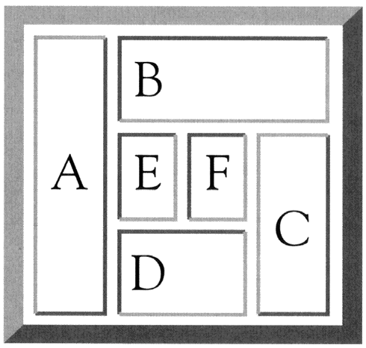

3. Design the following form:

Top of Form
Millennium Computers
Order Form
First Name
Last Name
Phone Number 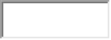
Computer Options
Processor Speed  1.5GHz  1.9GHz  2.5GHz  3.2GHz | Memory  64MB  128MB  256MB  512MB | Drive Size  15GB  30GB  60GB | Monitor Size  15-inch  17-inch  19-inch  21-inch | CD-ROM  24x  32x  48x  64x  72x
Credit Card
Card Number
Expiration Date /


